# CS 255 System Design Document Template

This template lays out all the different sections that you need to complete for Project Two. Each section has guidance to prompt your thinking. You will need to continually reference the interview transcript as you work to make sure that you are addressing your client’s needs. There is no required length for the final document. Instead the goal is to complete each section based on what your client’s needs are. Remove this note when you are finished, and replace all bracketed text with the relevant information.

## UML Diagrams

### UML Use Case Diagram

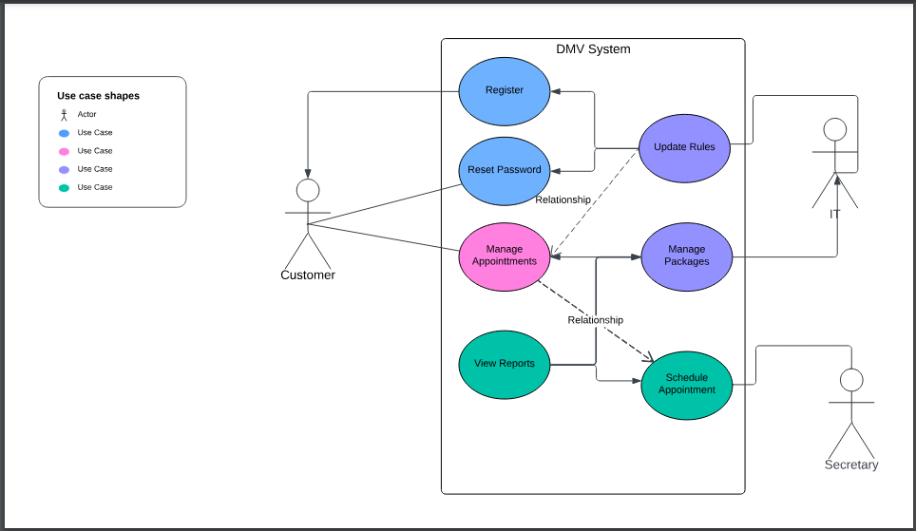

### UML Activity Diagrams

*Managing Appointment:*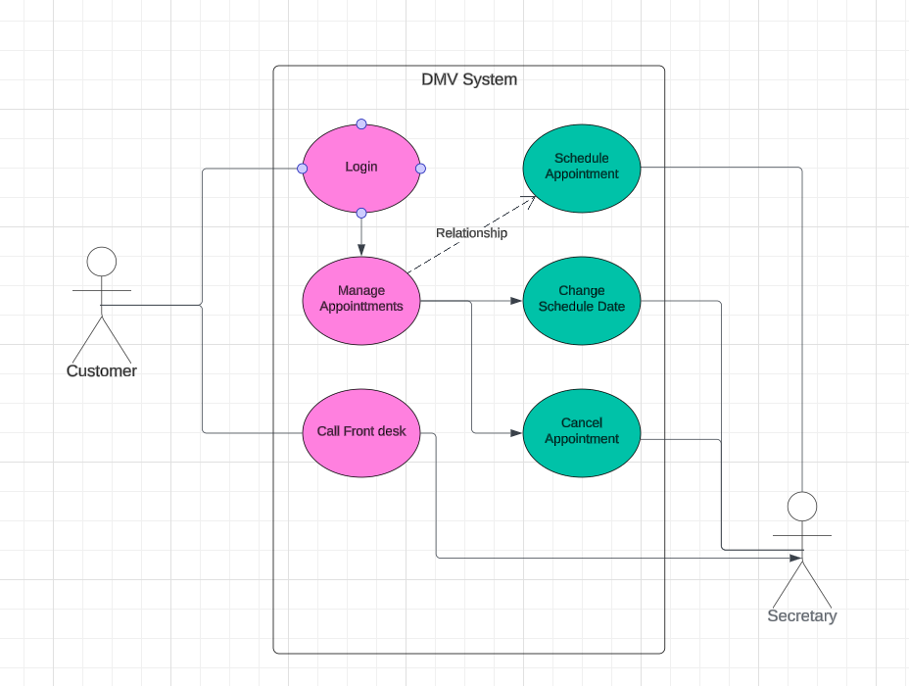

*Managing account (New User/Existing User)*

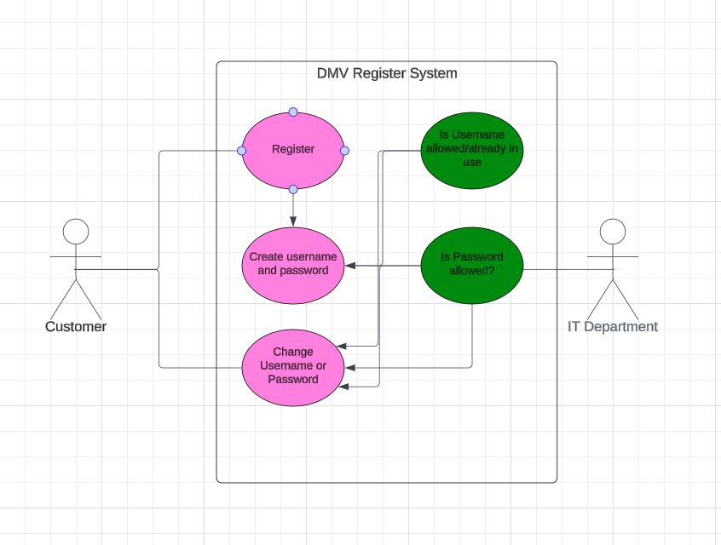

### UML Sequence Diagram

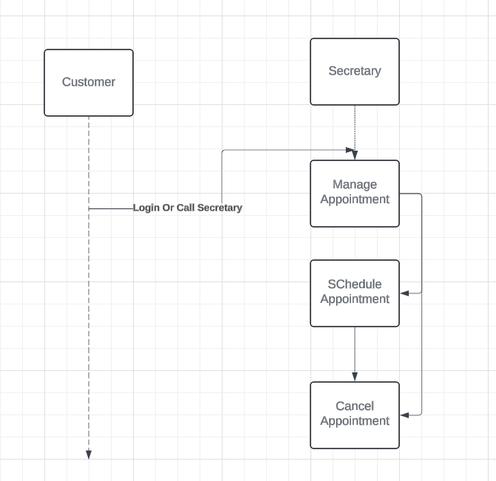

### UML Class Diagram

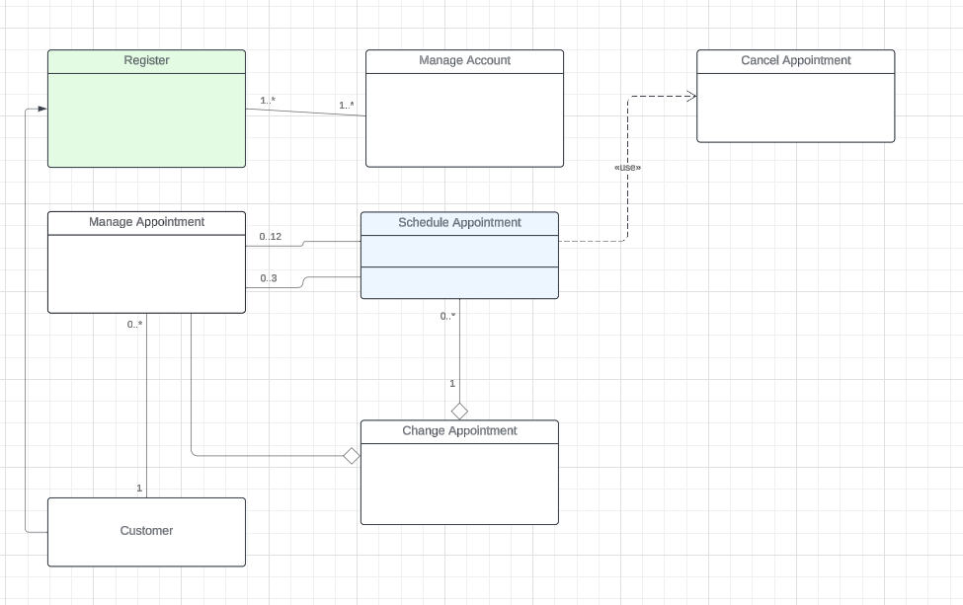

## Technical Requirements

*Based on our diagrams we have a few technical requirements. We require servers such as application servers, database servers, and a backup server. For software we require Linux for the backend and Windows and macOS for the customer. To manage the databases we will need MYSQL, and Apache for the web server software. We will need an application framework to which we will use python and for the front end we will need HTML, CSS, and JavaScript.*

*For Development tools we will need Pycharm for an IDE. Git for source code management. As well as Jira for project management tools. When it comes to infrastructure, we will need hosting and cloud services as well as load balancing and scaling. If anything goes wrong, we will need backup and disaster recovery.*

*For security requirements we need Authentication and authorization systems, data encryption, regular security audits, as well as monitoring and logging. For performance requirements we would need Redundant servers and failover mechanisms, a scalable infrastructure, and optimization. Finally for compliance regulations we would need data protection regulations and accessible standards.*